Exercise 10: DatabaseServlet Application using Tomcat Server

Write index.html to display form with a submit button. Set the method attribute of the form to “get” to generate GET request to the server. Write a java servlet to display the records of the table when the button is clicked. Also write the configuration file, namely, web.xml which maps the url mapped to the servlet class file. [CO2, K3]

Follow the directory structure for creating DatabaseServlet Web application and follow the guidelines below to configure and deploy web application.

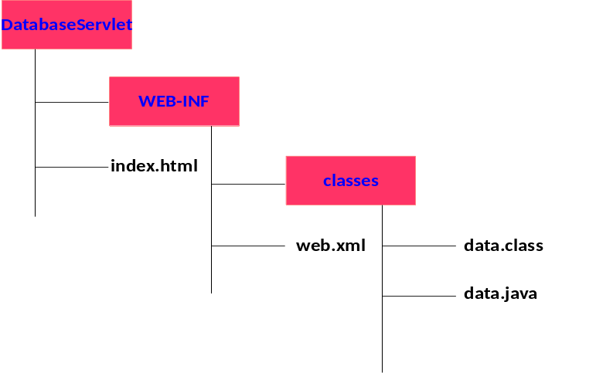

To install mysql server in ubuntu 16.04 environment
To install mysql server
sudo apt-get update
sudo apt-get install mysql-server
mysql_secure_installation
To check the mysql service
systemctl status mysql.service
To start and stop the service
service mysql start
service mysql stop
To get into the mysql prompt
mysql –u root –p
To clear the screen in mysql prompt
system clear
To exit from the mysql prompt
Exit
In /usr/share/java, there won’t be any mysql connector files available. In order to run the servlet code with the database, we need to have connector files in tomcat/lib folder

Execute the following statement to get the connector files
apt-get install Libmysql-java
You will have mysql.jar, mysql-connector-java.jar, mysql-connector-java-5.1.38.jar in /usr/share/java folder. Copy them and put it in tomcat/lib folder.

Start the server using $CATALINA_HOME/bin/startup.sh
To run DatabaseServlet navigate to the url : http://localhost:8080/DatabaseServlet
Stop the server using $CATALINA_HOME/bin/shutdown.sh

To install mysql server in windows environment
Use mysql-5.5.30-win32 to install mysql
Set the path of mysql in environment variables
While installing, provide user name and password
Copy the mysql-connector-java-3.1.14-bin jar file to “C:\Program Files\Apache Software Foundation\Tomcat 7.0\lib”
To run mysql go to StartAll Program MySqLMySql5.5 Command Line Client and double
click it
mysql> use test;
mysql> create table Employess (id int, age int, first varchar(20), last varchar(20));
mysql> insert into Employess (101, 20, “Zara”,”Ali”);
mysql> select * from Employees;
How to run the Web application?
1. Copy the DatabaseServlet application in webapps folder
2. Navigate to tomcat directory, go to bin
3. Execute startup.bat
4. Wait for the server to start
5. Open browser and navigate to the url : localhost:8080
6. A tomcat demo page will be displayed.
7. To run firstservlet navigate to the url : http://localhost:8080/DatabaseServlet

Best Practices to be followed:
- Design before coding
- Incremental coding
- Usage of proper naming convention
- Usage of Comments to the code

